Lab 13: Blind OS command injection vulnerabilities
Objective:
- This lab is centered around Blind Command Injection vulnerabilities, a more subtle form of command injection where the results of the injection are not directly visible to the attacker. Participants will engage with a simulated environment where an application is susceptible to blind command injection.
In this lab, students need to:
- Answer the following questions:
  - What is Blind Command Injection, and how does it differ from classic command injection vulnerabilities?
  - Discuss the challenges posed by Blind Command Injection, particularly in scenarios where the application does not return any direct output from executed commands. How can an attacker infer successful command execution in such cases.
- Perform challenge:
  - Blind OS command injection with time delays
- Explain and capture all steps (full windows screen capture).
Group Members:
- Phạm Hoàng Hải Nguyên (SE180511)
- Nguyễn Trúc Quỳnh (SE180280)
- Giã Thị Nhã Trân (SE180405)

Submit a report addressing all the questions mentioned above in either PDF or Markdown format. Additionally, include a video demonstrating the detailed process of your work to ensure the authenticity of your lab exercise.
The report file name must be Class_YourStudentID _YourName_Lab13

Blind OS command injection with time delays
This image shows the main shop page of the lab application while Burp Suite is monitoring HTTP traffic. The tester interacts with the website while observing the captured requests in the HTTP history tab to identify possible parameters that could be exploited for blind OS command injection.
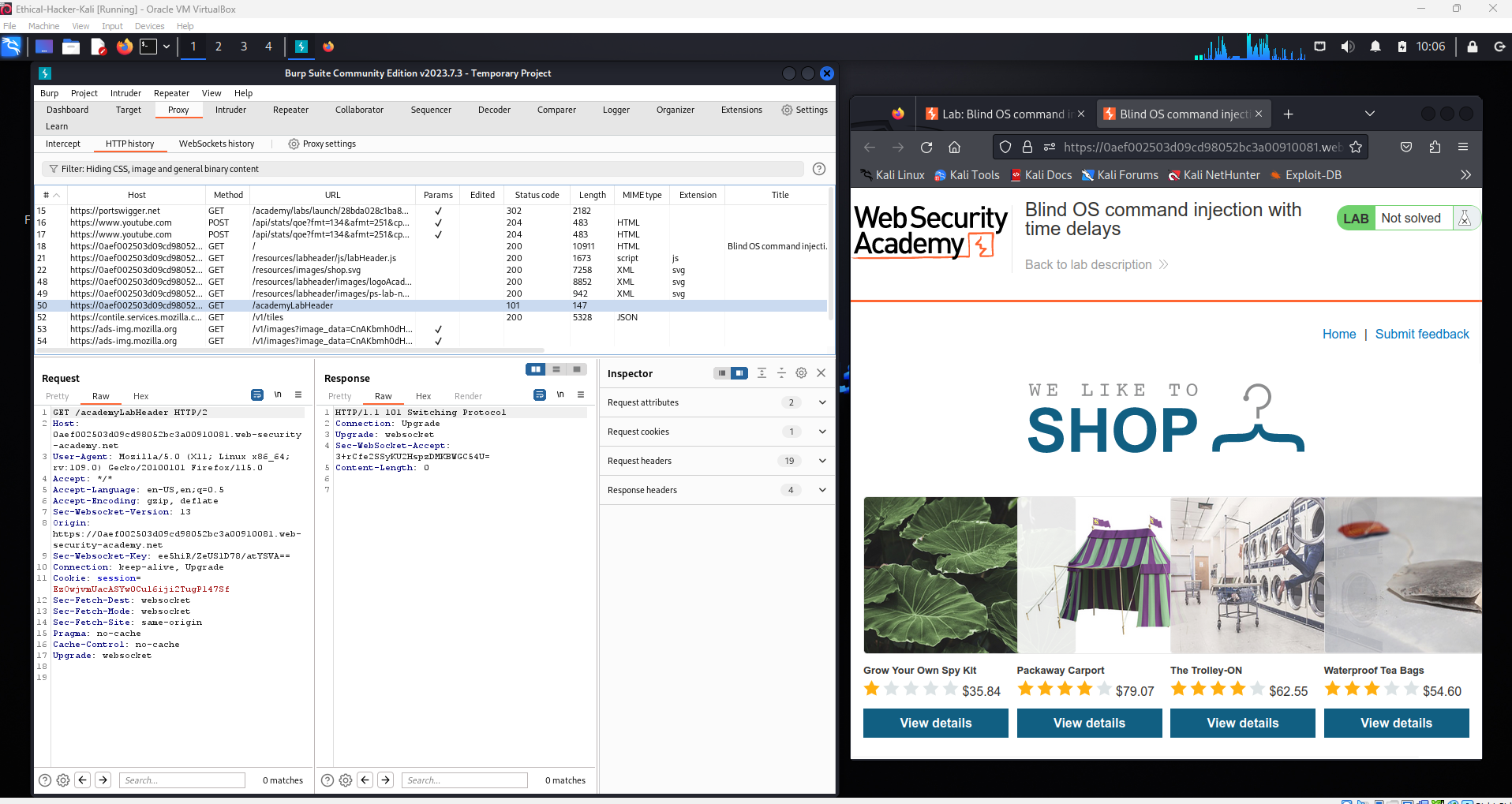

The tester fills in the feedback form with sample input while Burp Suite captures the HTTP request in the HTTP History tab. This step helps identify the request and parameters that may be tested for blind OS command injection vulnerabilities.
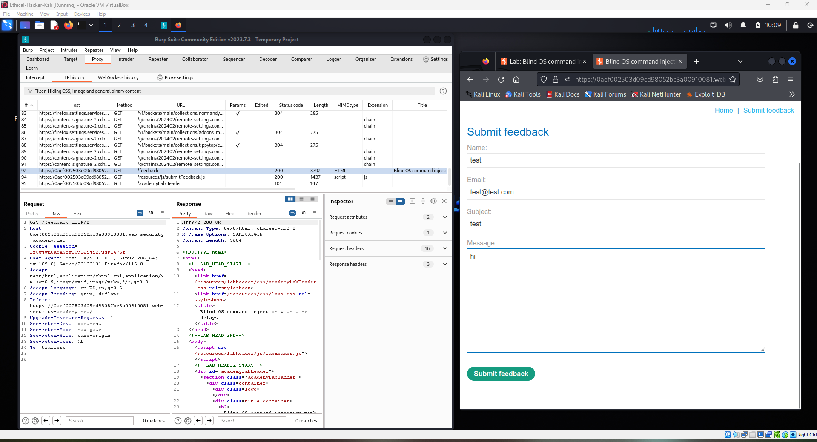
The captured request is sent to Burp Suite Repeater to allow manual testing and modification. The tester can edit the request parameters and resend it multiple times to check for potential blind OS command injection vulnerabilities.
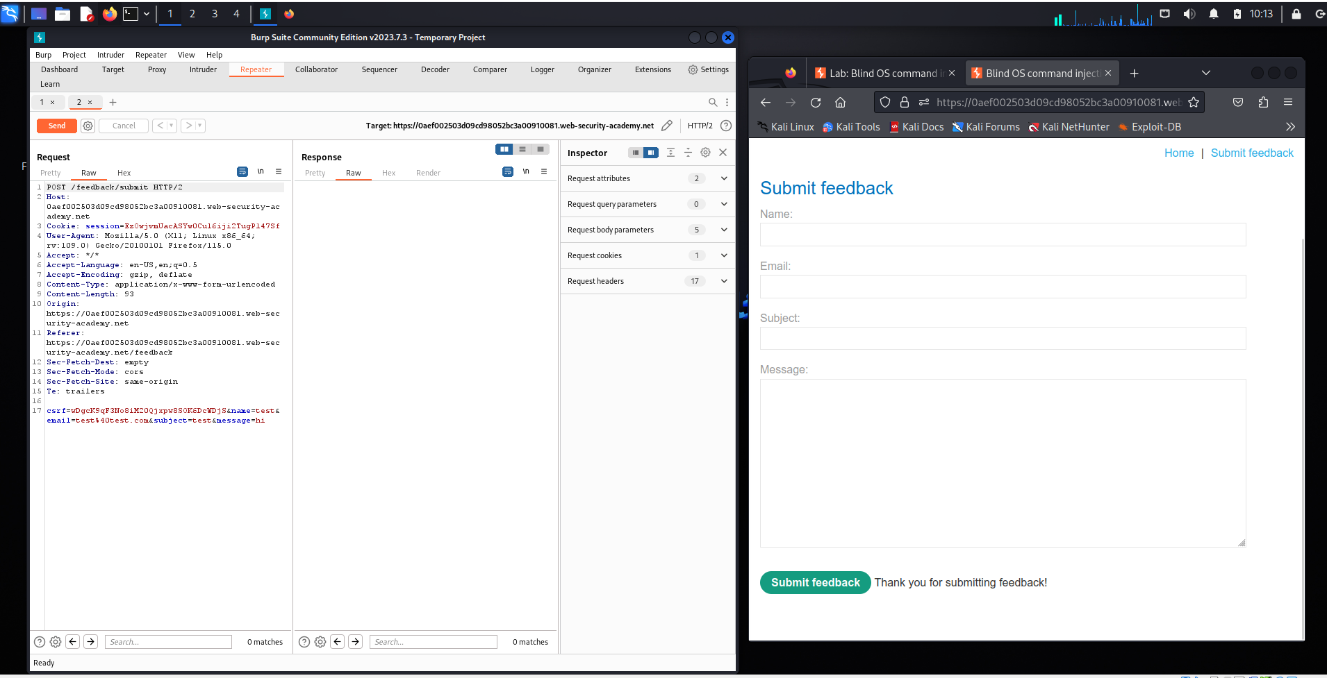

The intercepted request is analyzed and modified in Burp Suite Repeater. The tester can resend the request and observe the server response to determine whether the injected payload triggers a blind OS command injection vulnerability.
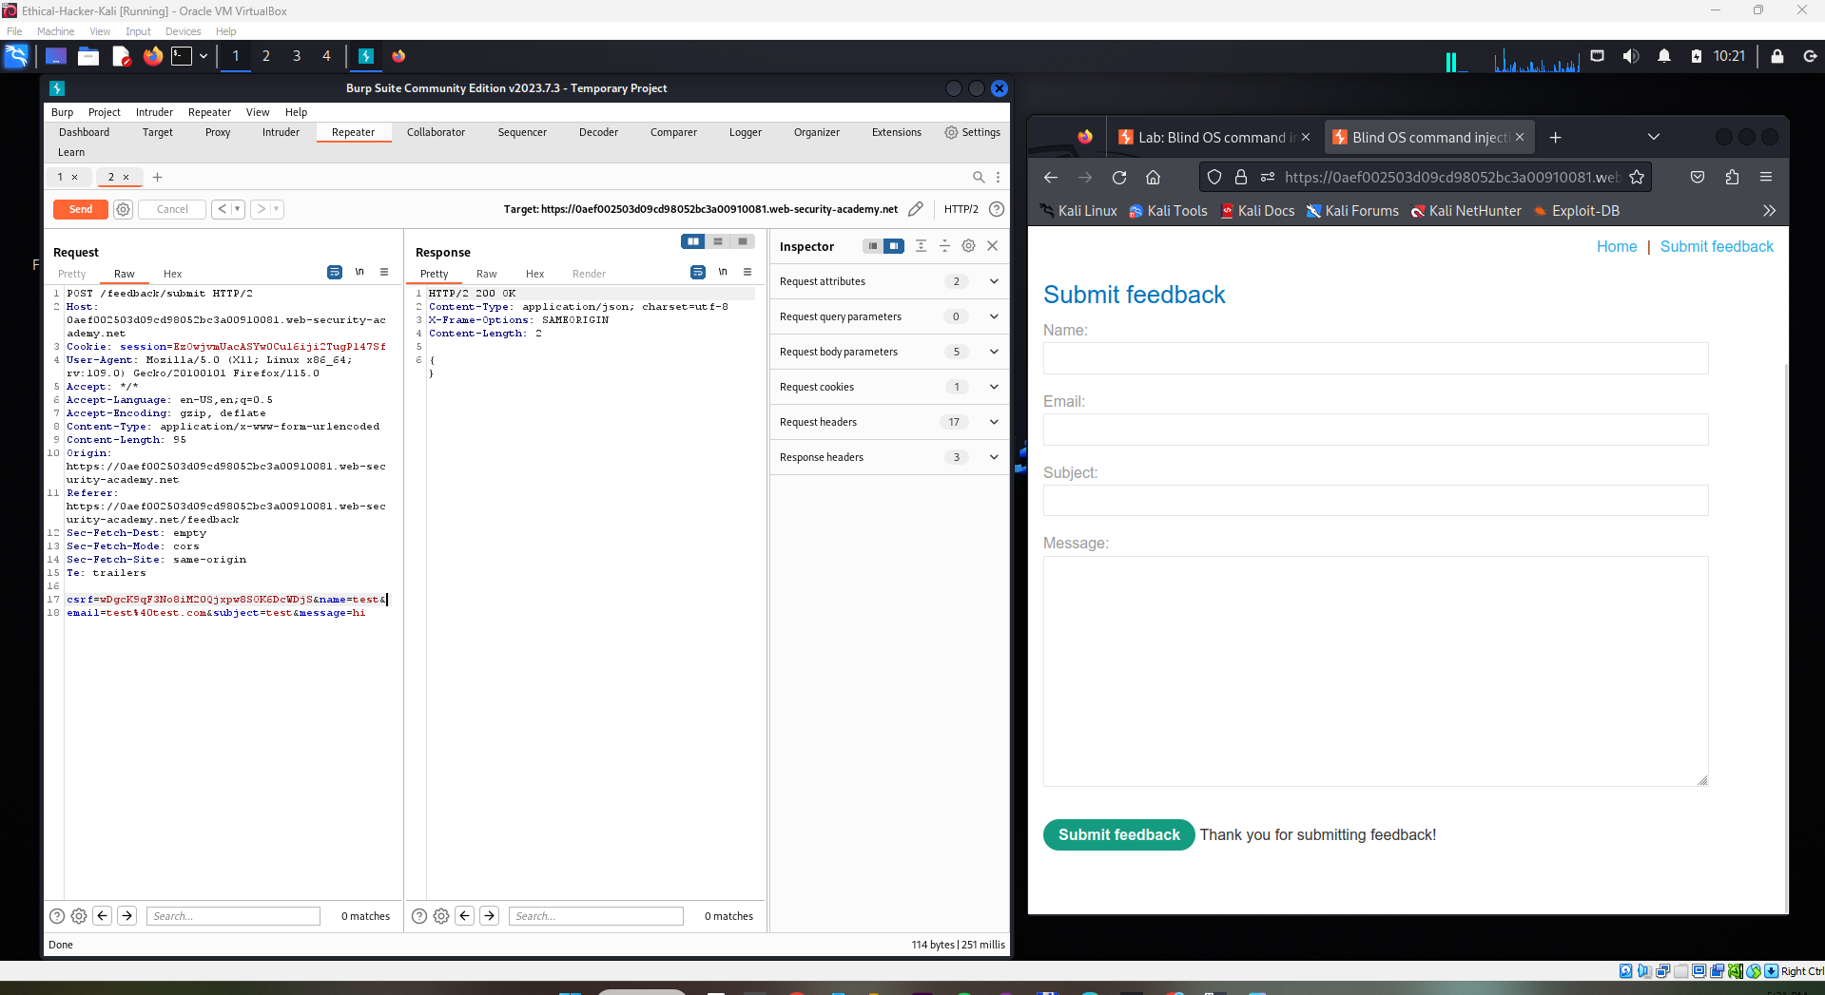

The request in Burp Suite Repeater sends user input to the server where a command injection payload is appended to the email parameter. The payload attempts to execute a system command and uses a delay technique, which helps verify Blind OS command injection even though no command output is returned.
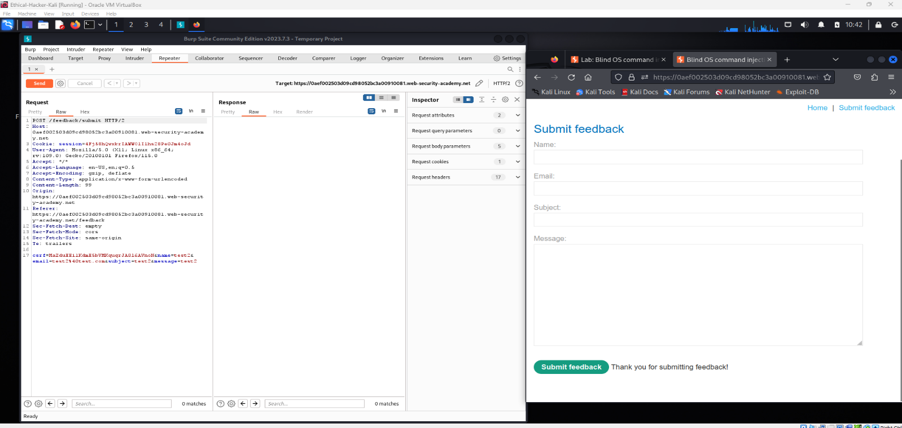
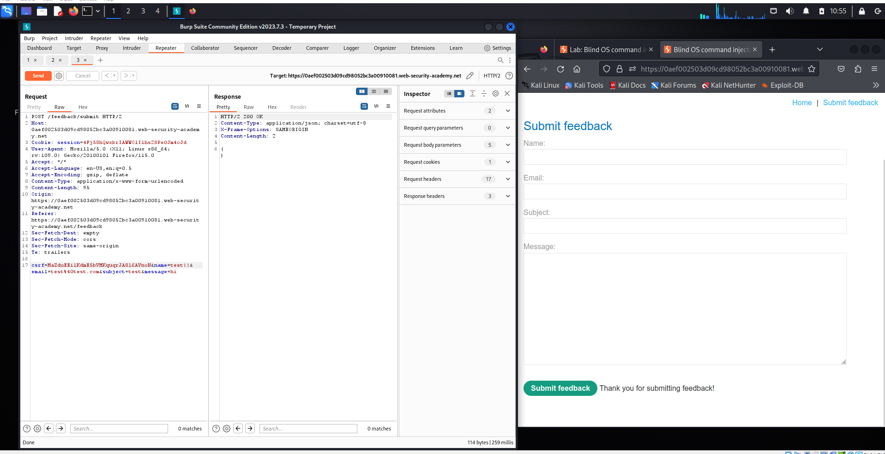
The request is intercepted and sent to Burp Suite Repeater to test the /feedback/submit endpoint with modified parameters. A command injection payload is appended to the name parameter using a time delay command, allowing verification of Blind OS command execution based on the server’s response time.

The modified request containing the command injection payload is sent through Burp Suite Repeater to the /feedback/submit endpoint. The server returns HTTP 500 Internal Server Error, indicating the payload affected backend processing and suggesting a potential command injection vulnerability.
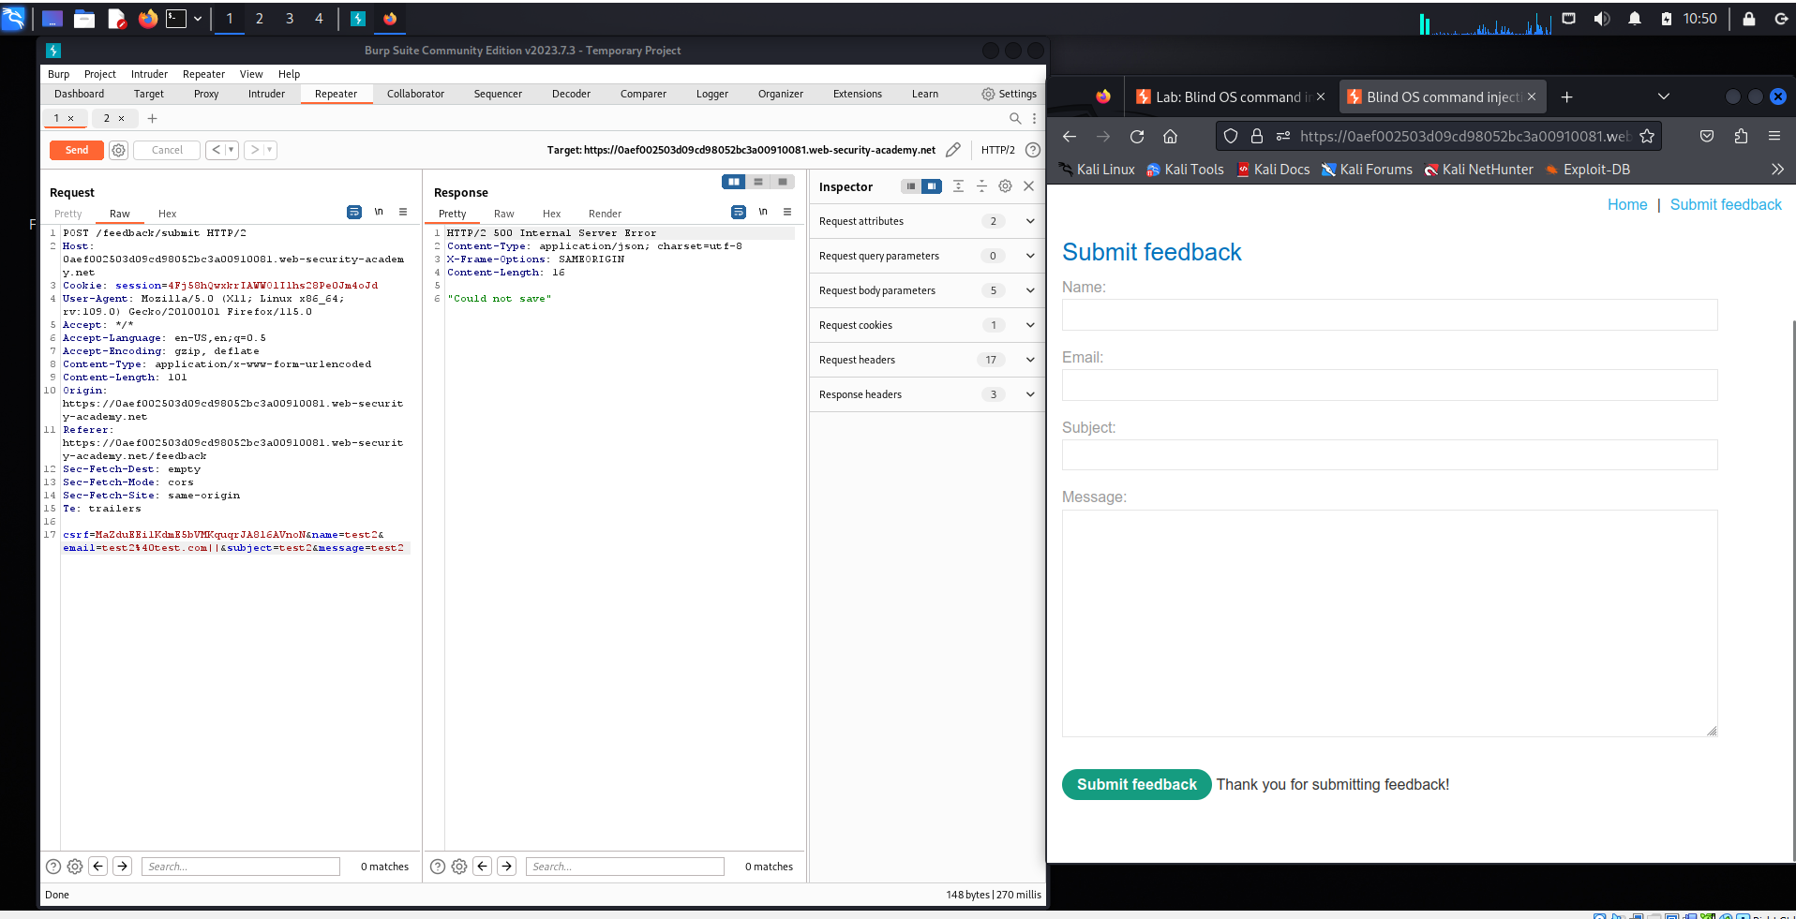
The request is tested again in Burp Suite Repeater with a modified payload inserted into the name parameter. The attacker sends the crafted input to observe the server behavior and determine whether the backend processes the injected command.
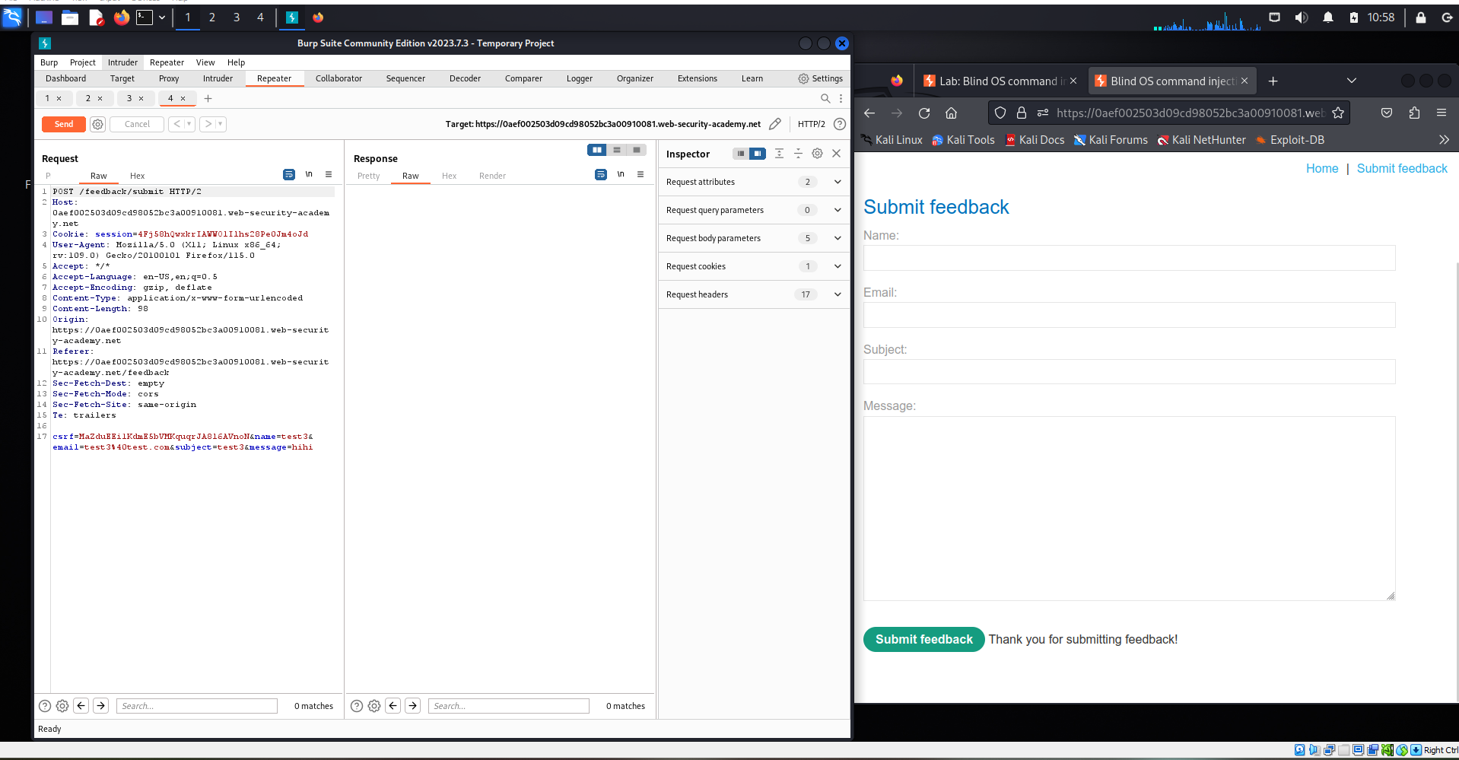

The payload ||ping+-c+10+127.0.0.1|| is injected into the email parameter to trigger a command execution with a time delay. The server response takes about 10 seconds, confirming that the injected OS command was executed successfully through Blind Command Injection.
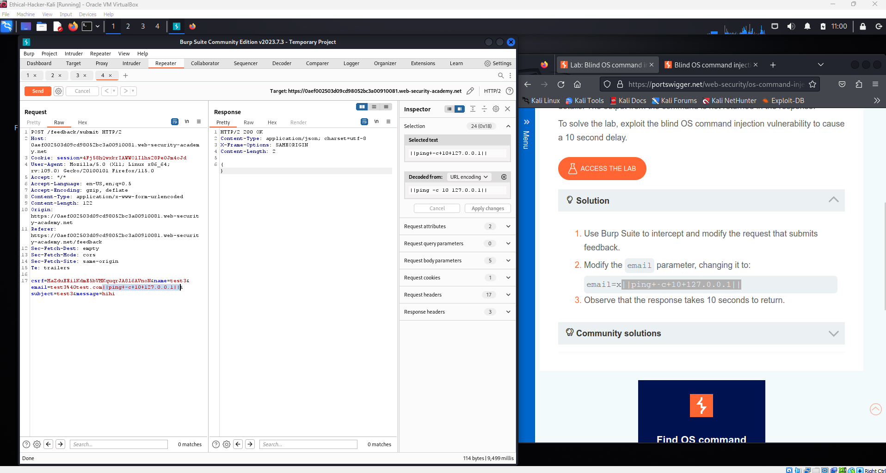
The injected payload successfully triggers a time delay, confirming that the OS command is executed on the server. The lab page displays “Congratulations, you solved the lab!”, indicating the Blind OS command injection vulnerability has been successfully exploited.
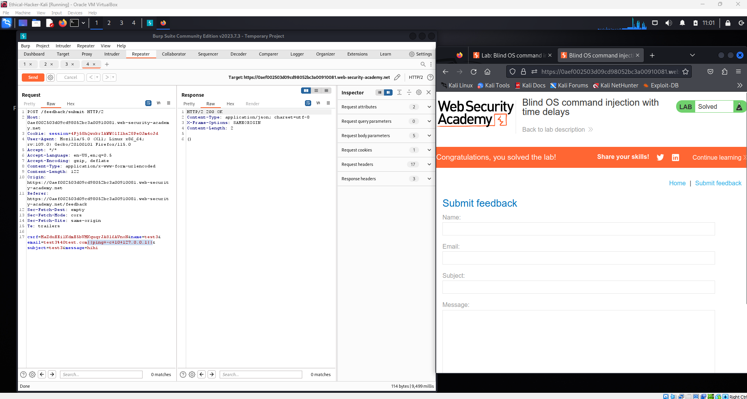
1. What is Blind Command Injection, and how does it differ from classic command injection vulnerabilities?
Blind Command Injection is a type of vulnerability where an attacker can execute operating system commands on the server, but the application does not return the command output in the HTTP response. Because of this, the attacker cannot directly see the result of the executed command.

This is different from classic command injection vulnerabilities, where the output of the executed command is displayed directly on the web page or in the server response. In classic command injection, attackers can immediately see the results of commands such as whoami or ls. In contrast, Blind Command Injection requires indirect methods to verify whether the command was executed successfully.

2. Challenges of Blind Command Injection and how attackers infer successful execution
Blind Command Injection is more difficult to exploit because the application does not display any output from executed commands. Attackers cannot directly see the results of their injected commands, which makes it harder to confirm whether the command was executed.

To overcome this challenge, attackers use indirect techniques to detect successful command execution. One common method is time-based injection, where a command such as sleep or ping is injected to create a delay in the server response. If the response takes longer than normal, it indicates that the command was executed. Another technique is out-of-band interaction, where the injected command forces the server to make a request to an external system controlled by the attacker, allowing them to detect the interaction.

3. Conclusion
In this lab, we learned how Blind OS Command Injection works and how attackers can exploit it even when the application does not return command output. By using Burp Suite to intercept and modify HTTP requests, we injected a payload into the input parameter and used a time-delay command to verify that the server executed the injected command. The delayed response confirmed the presence of the vulnerability. This lab helped us understand how dangerous command injection vulnerabilities can be and why proper input validation is essential in web applications.

4. Prevention Methods
To prevent Blind Command Injection vulnerabilities, developers should follow several security practices:
- Input validation and sanitization
All user inputs should be properly validated and sanitized to ensure they do not contain malicious characters or commands.
- Avoid executing system commands with user input
Applications should avoid directly passing user input to operating system commands.
- Use safe APIs instead of system calls
Developers should use built-in programming language functions instead of executing shell commands.
- Apply the principle of least privilege
The web application should run with minimal permissions to reduce the impact if an attack occurs.
- Use security testing tools
Regular security testing with tools such as Burp Suite or vulnerability scanners can help identify command injection vulnerabilities early.

